The best title you can imagine that fits in two lines with font Microsoft Sans Serif size 22
Presenter Lastname,¹ Contributor Lastname,² Contributor Lastname,³ and Principal Investigator Lastname*³
Use Microsoft Sans Serif size 10 for Authors. Underline whom will present the work at ICMS.

This example text has a lenght of 300 words.  Abstract text must be included here, singled spaced, 300 words of text as maximum. Franklin Gothic Book, size 10, align justify.  The citations should be consecutively numbered as superscripts,1 and should be detailed at the end using ACS format.  You can include Picture using any of this two columns enclosed in the round corner box.  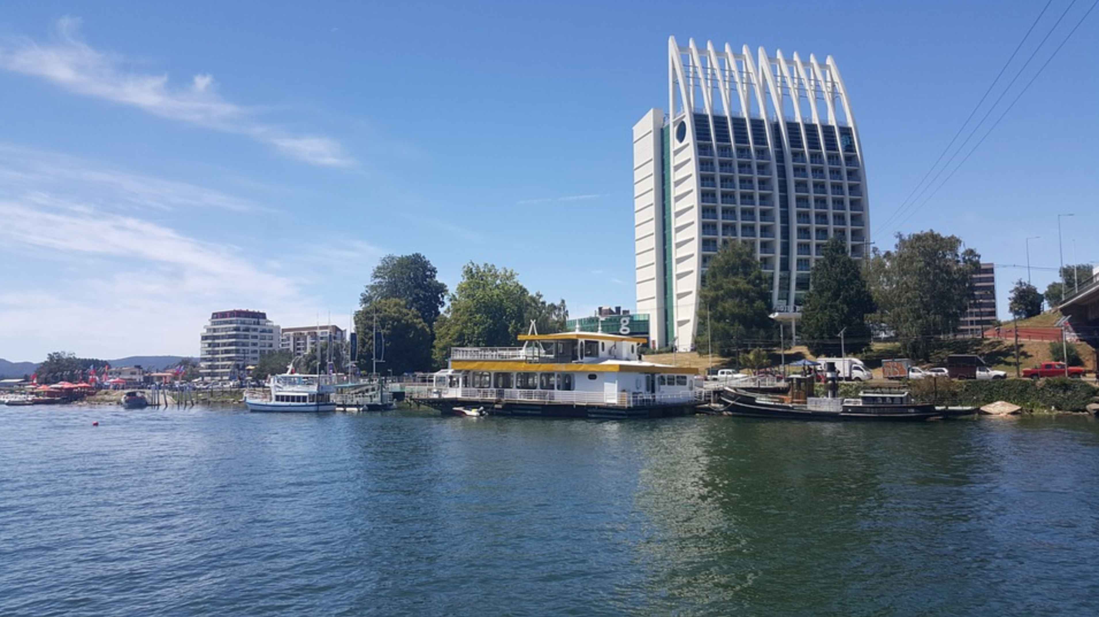  Figure Caption a free image from pixabay.com of the city of Valdivia.  [Franklin Gothic Book, size 9, align center]  Maximum size for image 4 cm height |  | The text of the abstract should describe the nature of the presenter’s oral or poster presentation, together with citations, if relevant.  Please do not deviate from the formatting outlined in this template; abstracts that deviate from this format will be returned for revision.  Just to complete the space, we include a nice text from the book "Surely You're Joking, Mr. Feynman!"  I gave a series of lectures in physics that the Addison­Wesley Company made into a book, and one time at lunch we were discussing what the cover of the book should look like. I thought that since the lectures were a combination of the real world and mathematics, it would be a good idea to have a picture of a drum, and on top of it some mathematical diagrams ­­ circles and lines for the nodes of the oscillating drumheads, which were discussed in the book.  The book came out with a plain, red cover, but for some reason, in the preface, there's a picture of me playing a drum. I think they put it in there to satisfy this idea they got that "the author wants a drum somewhere." Anyway, everybody wonders why that picture of me playing drums is in the preface of the Feynman Lectures, because it doesn't have any diagrams on it, or any other things which would make it clear.

Corresponding Author  presenter.lastname@someuniversity.com  Addresses  1. Some University, Faculty of Sciences and some Research, Any Street on Any City on the world, at some country in any planet of the Milky way.  2. Some University, Faculty of Sciences and some Research, Any Street on Any City on the world, at some country in any planet of the Milky way.  3. Use Franklin Gothic Book, size 9, align left. |  | References  - S. Omeone, S. Omeone-Again and S. Omebody-Else, Journal of Some Weird Science, 2017, 3, 540-550  - Use Franklin Gothic Book, size 9, align left.  - Use Franklin Gothic Book, size 9, align left.  - Use Franklin Gothic Book, size 9, align left.  - Use Franklin Gothic Book, size 9, align left. |  | Acknowledgements  We use Franklin Gothic Book, size 9, align left, to kindly acknowledge the contribution of several Grants with any number such as 11242657 from some Agency or Company from any place in the world. Also we would like to thanks to some researcher that allow us to use their very expensive and unique machine to carry out some measurements that we are presenting here.

